# Evaluation of forecasting methods

## Time series analysis

Time series may exhibit trend, seasonal and irregular components. In the following we will investigate methods that apply to the given time series and extract promising components.

### Trend analysis

The original, unedited time series of energy prices in belgium in 2010 is depicted in Figure 1.

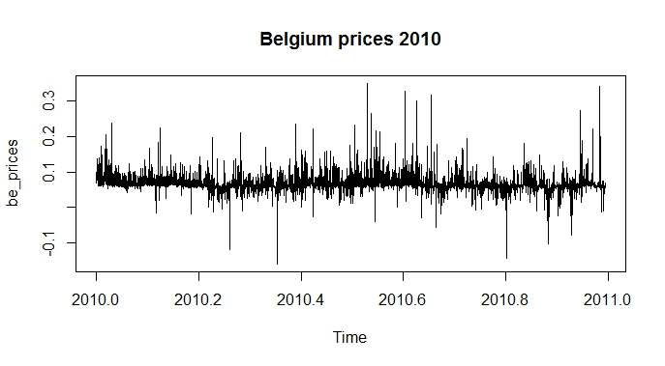

Figure 1: Belgian energy prices over 1 year

This time series shows a strong irregular component and small trends throughout the observed time range, however there is no seasonal behavior associated as energy prices are traded on a daily basis and do not exhibit any repetitive patterns over a season.

For a trend analysis we apply the Simple Moving Average (SMA) method to average out random fluctuations and reveal trends in the data.

The SMA method is configured with a moving window of a specific size to smooth out any disturbing variations in the data. Since the total number of observations exceeds 8000 (number of hours over a year) the window sizes were configured to n=10, n=100 and n=600. The results are shown below.

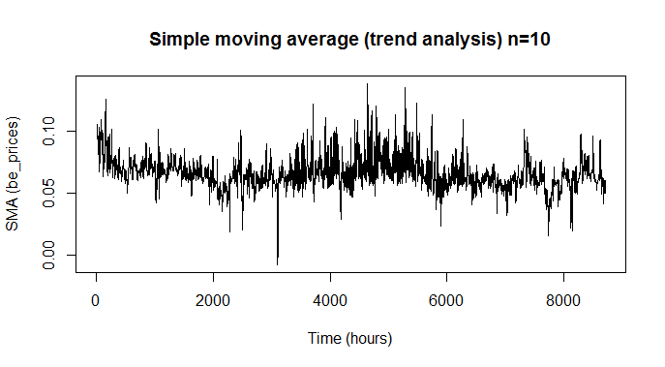

Figure 2: Simple moving average, sliding window size = 10

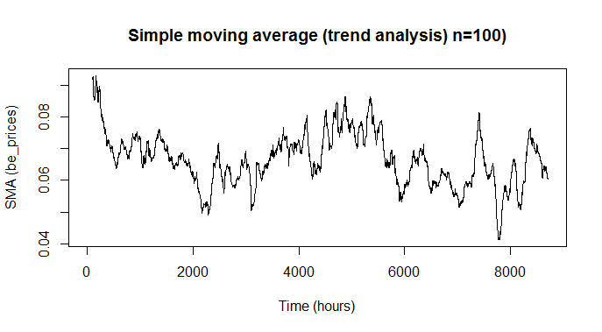

Figure 3: Simple moving average, sliding window size = 100

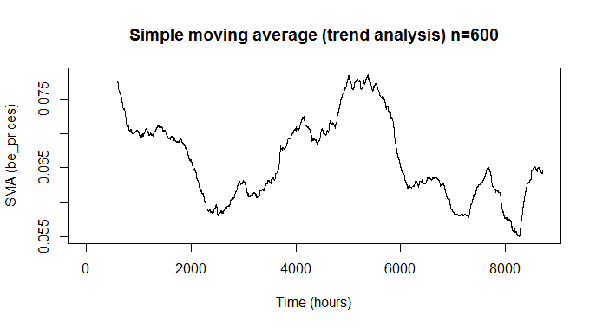

Figure 4: Simple moving average, sliding window size = 600

From the results we can deduce that the dataset exhibits a trend which may help in generating an appropriate forecasting model.

## Forecasting models

### Simple Exponential Smoothing

Time series with a constant level and roughly constant variations over time can be described by an additive model and thus can be applied to the Simple Exponential Smoothing (SES) model.

Simple Exponential Smoothing is based on the HoltWinters method but without considering trend and seasonal components.

We constrain the belgium energy prizes to the first 200 observations in order to get some visibly usable results (Figure 5) .

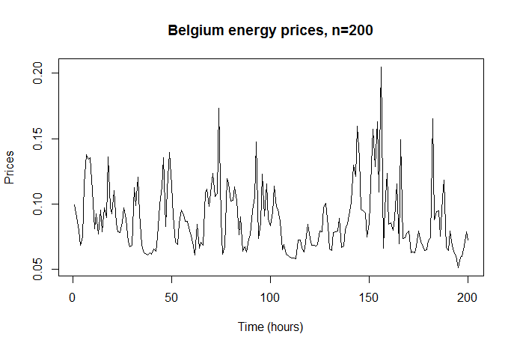

Figure 5: First 200 hours of energy prices in belgium, starting January 2010

Figure 6 depicts the results of applying an SES model to the belgian time series.

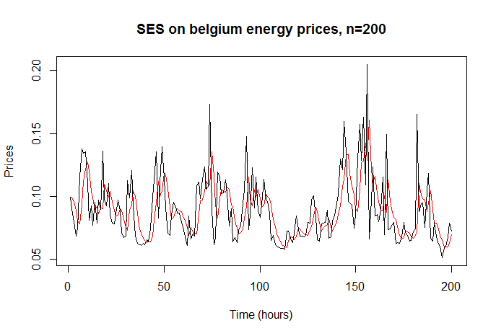

Figure 6: SES applied to belgian energy prices

In Figure 6 the black line shows the original time series whereas the red line denotes the predicted time series based on SES. It can be observed that the SES series lags behind the original series by some degree and some random fluctuations are averaged out additionally.

In Figure 7 an SES forecast beyond the given data is applied to this series. The blue line shows the actual forecast of energy prices whereas the dark and light blue shaded areas denote the 80% and 95% confidence intervals, respectively.

Remarkably the forecast just consists of a straight line, having the same value as the original series’ last observation. This is due to the model being trained without considering trend and seasonality components in the series, so the dataset is actually expected to have constant mean and variation.

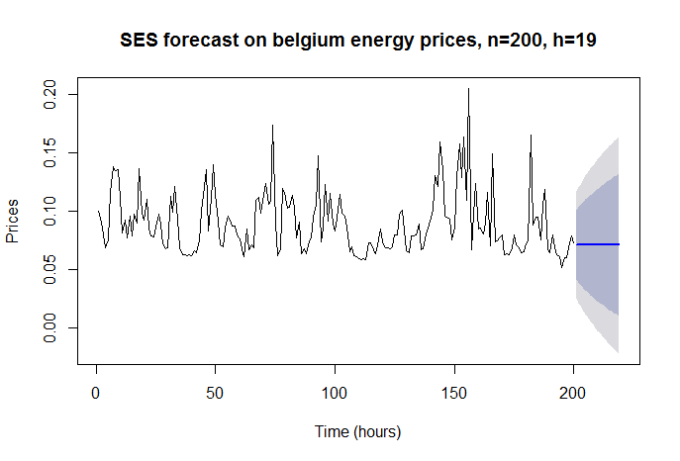

Figure 7: Forecasting 19 hours of belgian energy prices

However, since this dataset does neither have a constant mean nor constant variation, it would first have to be transformed into a series appropriate for this model. A common approach to achieve this is to differentiate the series one or more times, which has to be transformed back after the forecasting is done.

In this case, we differentiate the series one time. The results are shown in Figure 8.

From the results we can estimate that the resulting series does have a constant mean and constant variation on average. After applying the SES model to this time series the predicted values smooth out all random fluctuations and take values at the approximated mean of the series (Figure 9).

The actual forecast using SES based on the differentiated series is again a straight line, but since the series has zero mean and near constant variance this can be taken as reasonable forecast. Also, the prediction intervals stay the same with increasing forecast window size due to the series constant variance and mean. When transforming the data back to the original series the forecasted values have to be transformed as well to obtain the forecasts of the original dataset.

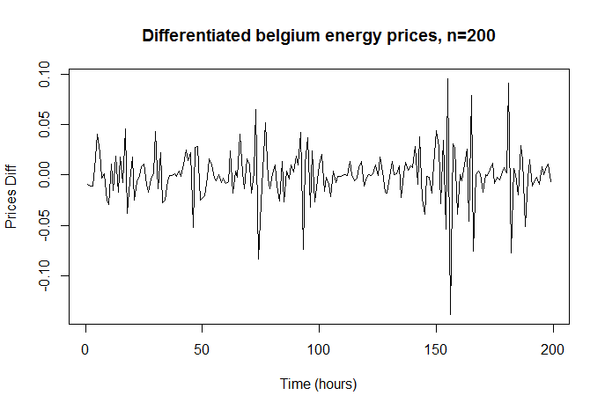

Figure 8: Belgian energy prices, one time differentiated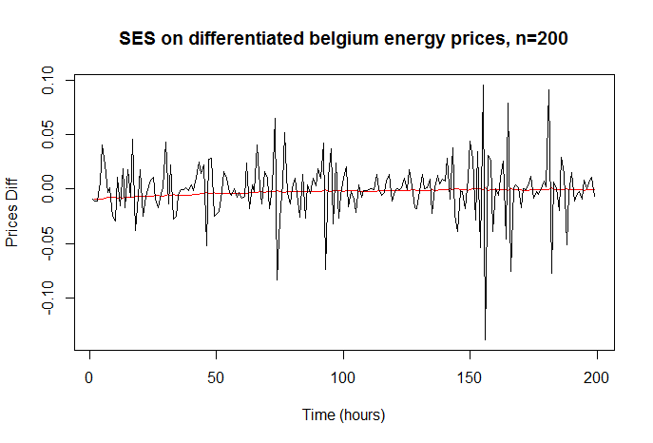

Figure 9: SES model applied to differentiated time series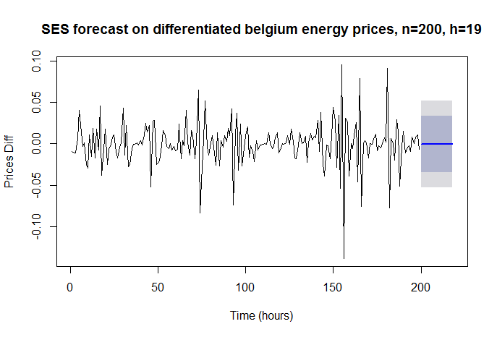

Figure 10: Forecast on differentiated time series, 19 intervals into the future

## Model Verification

Prediction models can be verified if they provide a good fit to the given data by applying accuracy measurements and investigating certain characteristics of the models.

## Accuracy

Calculating accuracy of forecasting models is a way to see how well the model captures the characteristics of the examined dataset. The key for calculating the accuracy of a model is to investigate the value difference between the actual and forecasted data points. The gaps between the actual and predicted data points are called residuals or forecast errors, from which accuracy measures can be directly derived.

### Residual characteristics

Residuals or forecast errors should have two characteristics such that the model is using all available information from the data:

* Residuals of a forecast should be uncorrelated such that there are no errors depending on other forecasting errors
* Residuals should exhibit a zero mean such that errors are spread evenly on average

In addition, for easier calculation of prediction intervals, residuals should exhibit the following two characteristics:

* Residuals are normally distributed over the given timeframe
* Residuals show constant variance

If one of these features is false the prediction model can possibly be improved. Compliance with above points just gives affirmation that the prediction model is sufficiently valid for the given dataset, it does not mean that it cannot be improved.

### Checking Correlation of forecasting errors

A correlogram of residuals is obtained by calculating an auto-correlation function on the set of residuals for a minium and maximum amount of lags. (insert graphic)

A significance test is carried out to test if there is significant evidence for the set of residuals being uncorrelated. This can be done by the Ljung-box test which is a statistical test for autocorrelation of a time series.

One of the outputs of the Ljung-box test is the so called p-value which is a value between 0 and 1 where the more there is evidence for correlation the closer the value gets to zero. Thus, a value close to one indicates very little evidence for dependency between lags.

## Forecasting test

Now we will take energy price data from the PJM power market in the US and based on that apply different forecasting methods at different time scales.

We will take US power data from the city of Detroit for various time intervals, which are one week, two weeks, one month, three months, and six months.

## Forecasts by time range

### One week power data

### Autocorrelation Tests

## ARIMA models

An ARIMA model may be applied to stationary time series only as it is considered to be an additive model that adds the irregular component to the calculation of the forecasting model. This irregular component is represented by an artificial time series with zero mean and constant variance which is added to the model in order to account for random fluctuations in the dataset. Thus, the dataset to be examined must also be stationary, that is it has to exhibit a near constant level and variance.

**Formal tests for stationarity**

There are formal tests available to determine if a given dataset has stationary characteristics to a sufficient degree to be applied appropriately i.e. to an ARIMA model. These are so called *unit root tests* since they are basic tests to evaluate the characteristics of a dataset in terms of stationarity.

### Moving average models

*“We use the principle of parsimony to decide which model is best: that is, we assume that the model with the fewest parameters is best. The ARMA(3,0) model has 3 parameters, the ARMA(0,1) model has 1 parameter, and the ARMA(p,q) model has at least 2 parameters. Therefore, the ARMA(0,1) model is taken as the best model.”*

*“An ARMA(0,1) model is a moving average model of order 1, or MA(1) model. This model can be written as: X_t - mu = Z_t - (theta * Z_t-1), where X_t is the stationary time series we are studying (the first differenced series of ages at death of English kings), mu is the mean of time series X_t, Z_t is white noise with mean zero and constant variance, and theta is a parameter that can be estimated.”*

An ARMA(0,1) model is a moving average model of order one since only one step before the current data point is taken into account. The moving average is applied to the irregular series Z_t having constant mean and variation, to account for random fluctuations in the data.

Since the irregular series Z_t is added in the calculation, the examined dataset needs to have a near constant mean and variation.

### Autoregressive models

*“The ARMA(2,0) model has 2 parameters, the ARMA(0,3) model has 3 parameters, and the ARMA(p,q) model has at least 2 parameters. Therefore, using the principle of parsimony, the ARMA(2,0) model and ARMA(p,q) model are equally good candidate models.”*

*“An ARMA(2,0) model is an autoregressive model of order 2, or AR(2) model. This model can be written as: X_t - mu = (Beta1 * (X_t-1 - mu)) + (Beta2 * (Xt-2 - mu)) + Z_t, where X_t is the stationary time series we are studying (the time series of volcanic dust veil index), mu is the mean of time series X_t, Beta1 and Beta2 are parameters to be estimated, and Z_t is white noise with mean zero and constant variance.”*

*“An AR (autoregressive) model is usually used to model a time series which shows longer term dependencies between successive observations. “*

An ARMA(2,0) model is an autoregressive model of order two because in the calculation there are two additional steps of the time series considered, each weighted with a coefficient (Beta1 and Beta2). It is auto-regressive since the calculation is based on the series $X_{t}$ itself and thus considers history values up to the order of the autoregression.